Terraform challenge
- Create an EC2 Instance on AWS Cloud using the below-mentioned ubuntu AMI and instance_type. Or, (You can use of your choice as well) ami = "ami-0461b1436c9b3c1a3" instance_type = "t2.micro"
- Install a web server on the same EC2 Instance. The web server should listen on port 8080.
- Create a Docker-compose file for the project: https://github.com/betawins/cricbuzz-docker-hello-world.git and point it to port 8000.
- Make the web server point to the above service so that 8080 returns the response from the Docker service.
- Configure to Save the Logs in the location /var/log/cb.log
- Write the Log rotate configuration for the above file.

Challenge architecture
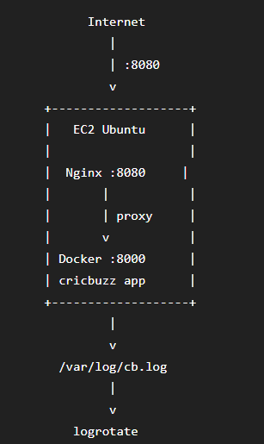

What we need to implement
- Terraform creates EC2
- Security Group allows SSH 22 and HTTP 8080
- EC2 installs:
  - Docker
  - Docker Compose
  - Nginx
  - Git
- Clone cricbuzz-docker-hello-world
- Create docker-compose.yml
- Run application on port 8000
- Configure Nginx on 8080
- Nginx proxies 8080 → 8000
- Save Nginx access/error logs to /var/log/cb.log
- Configure logrotate
Task 1: Create an EC2 Instance on AWS Cloud using the below-mentioned ubuntu AMI and instance_type. Or, (You can use of your choice as well) ami = "ami-0461b1436c9b3c1a3" instance_type = "t2.micro".

Create an EC2 Instance on AWS

Objective
Create an Ubuntu EC2 instance using Terraform with:
- AMI: ami-0461b1436c9b3c1a3
- Instance type: t2.micro
- Region: us-east-1
- SSH access through a security group
- Public IP enabled

Expected Outcome
At the end of Task 1:
Terraform
↓
AWS EC2
↓
Ubuntu t2.micro
↓
Public IP
You should be able to SSH into the instance.

1.1 Create the Terraform directory
From Git Bash:
mkdir terraform-cricbuzz
cd terraform-cricbuzz
Create these files:
terraform-cricbuzz/
├── provider.tf
├── variables.tf
├── main.tf
└── outputs.tf

1.2 Create provider.tf
terraform {
required_providers {
aws = {
source = "hashicorp/aws"
}
}
}

provider "aws" {
region = "us-east-1"
}
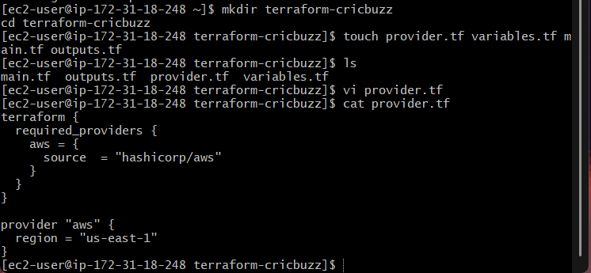

1.3 Create variables.tf
variable "ami" {
description = "Ubuntu AMI ID"
type = string
default = "ami-0461b1436c9b3c1a3"
}

variable "instance_type" {
description = "EC2 instance type"
type = string
default = "t2.micro"
}

variable "key_name" {
description = "AWS EC2 key pair name"
type = string
default = "challenge"
}
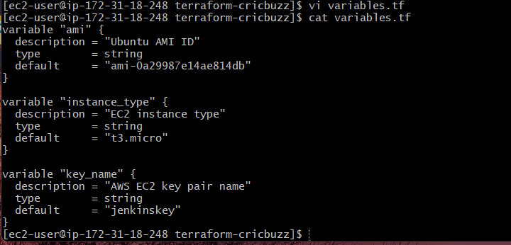

1.4 Create main.tf
resource "aws_security_group" "cricbuzz_sg" {
name = "cricbuzz-sg"
description = "Security group for Cricbuzz Terraform challenge"

ingress {
description = "SSH"
from_port = 22
to_port = 22
protocol = "tcp"
cidr_blocks = ["0.0.0.0/0"]
}

egress {
from_port = 0
to_port = 0
protocol = "-1"
cidr_blocks = ["0.0.0.0/0"]
}

tags = {
Name = "cricbuzz-sg"
}
}

resource "aws_instance" "cricbuzz_server" {
ami = var.ami
instance_type = var.instance_type
key_name = var.key_name
vpc_security_group_ids = [aws_security_group.cricbuzz_sg.id]

tags = {
Name = "cricbuzz-server"
}
}
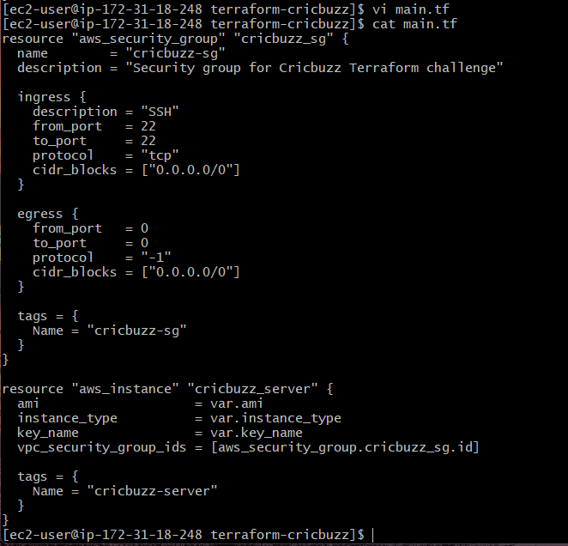

1.5 Create outputs.tf
output "instance_id" {
value = aws_instance.cricbuzz_server.id
}

output "public_ip" {
value = aws_instance.cricbuzz_server.public_ip
}

output "public_dns" {
value = aws_instance.cricbuzz_server.public_dns
}
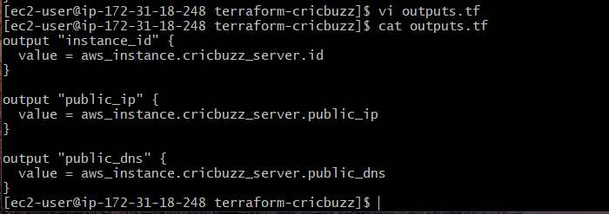

1.6 Initialize Terraform
Run:
terraform init
Expected:
Terraform has been successfully initialized!
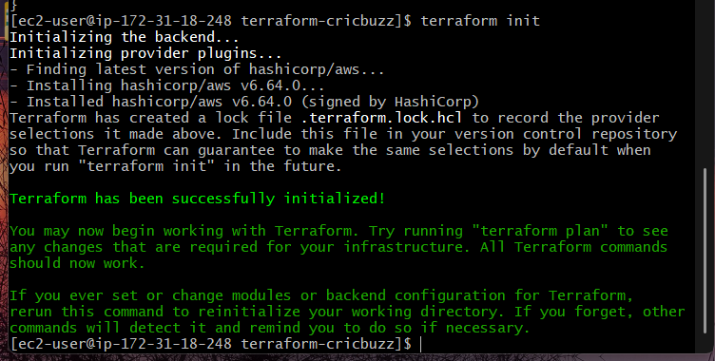

1.7 Validate the configuration
terraform validate
Expected:
Success! The configuration is valid.

1.8 Review the plan
terraform plan
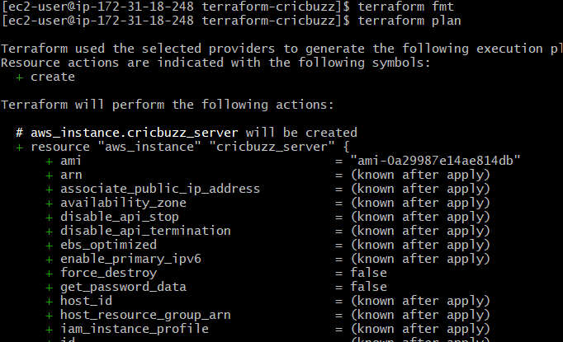
You should see approximately:
Plan: 2 to add, 0 to change, 0 to destroy.
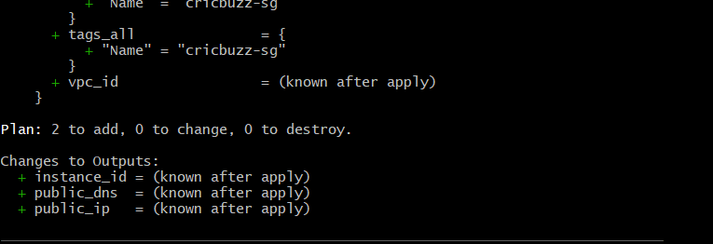
The two resources are:
aws_security_group.cricbuzz_sg
aws_instance.cricbuzz_server

1.9 Create the EC2 instance
terraform apply
When prompted:
Do you want to perform these actions?
Enter:
yes
Expected:
Apply complete! Resources: 2 added, 0 changed, 0 destroyed.
You should also get:
instance_id = "i-xxxxxxxxxxxxxxxxx"
public_ip = "x.x.x.x"
public_dns = "ec2-x-x-x-x.compute-1.amazonaws.com"
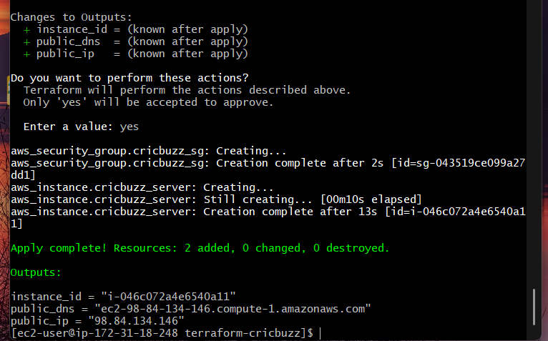

1.10 Verify the EC2 instance
You can verify from AWS CLI:
aws ec2 describe-instances \
--filters "Name=tag:Name,Values=cricbuzz-server" \
--query "Reservations[].Instances[].{ID:InstanceId,State:State.Name,IP:PublicIpAddress,Type:InstanceType}" \
--output table
Expected:
------------------------------------------------
| DescribeInstances |
+----------------------+-----------------------+
| ID | i-xxxxxxxxxxxxxxxxx |
| State | running |
| IP | x.x.x.x |
| Type | t2.micro |
+----------------------+-----------------------+
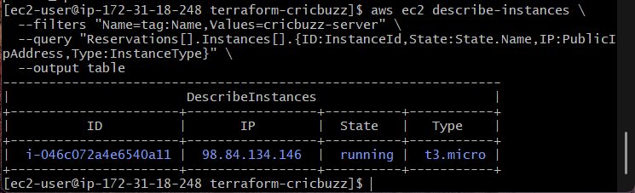
Now we have
- Terraform initialized
- terraform validate successful
- EC2 created successfully
- Security group created
- Instance is running
- Public IP obtained
- You can SSH into the Ubuntu instance

Task 2: Install a web server on the same EC2 Instance. The web server should listen on port 8080.

Objective
Install a web server on the EC2 instance created in Task 1 and configure it to listen on:
Port: 8080
For this challenge, we'll use Nginx.

Expected Outcome
Internet
↓
EC2 Public IP:8080
↓
Nginx
↓
Test response

2.1 SSH into the EC2 instance
Use the public IP from Task 1:
ssh -i "challenge.pem" ubuntu@<PUBLIC-IP>
Example:
ssh -i "challenge.pem" ubuntu@54.xx.xx.xx
Verify:
whoami
Expected:
Ubuntu
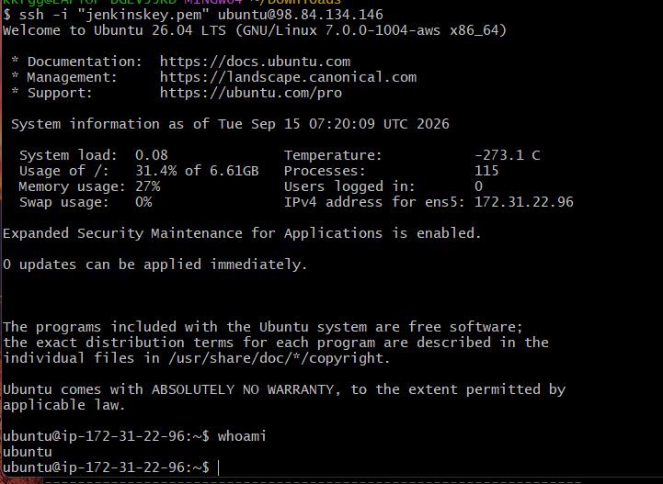

2.2 Update the packages
sudo apt update

2.3 Install Nginx
sudo apt install nginx -y
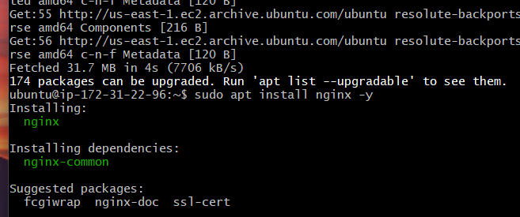
Check the service:
sudo systemctl status nginx
You should see:
Active: active (running)
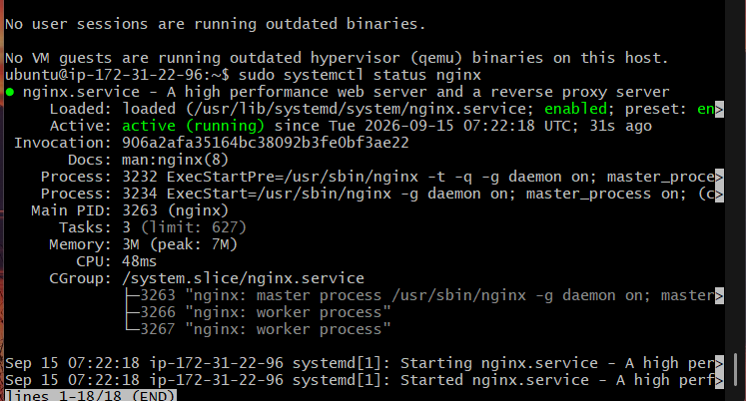

2.4 Change Nginx to port 8080
Open the default Nginx configuration:
sudo nano /etc/nginx/sites-available/default
Find:
listen 80 default_server;
listen [::]:80 default_server;
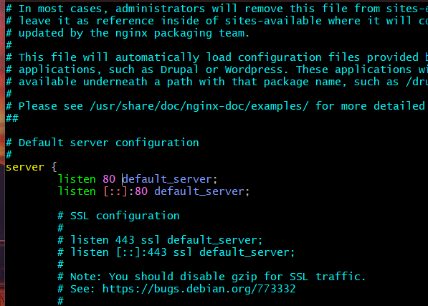
Change it to:
listen 8080 default_server;
listen [::]:8080 default_server;
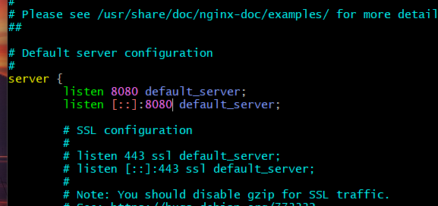
Save:
Ctrl + O → Enter → Ctrl + X

2.5 Test the Nginx configuration
sudo nginx -t
Expected:
syntax is ok
test is successful
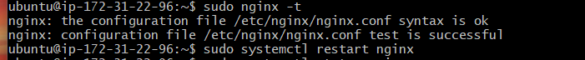

2.6 Restart Nginx
sudo systemctl restart nginx
Check:
sudo systemctl status nginx
Expected:
Active: active (running)
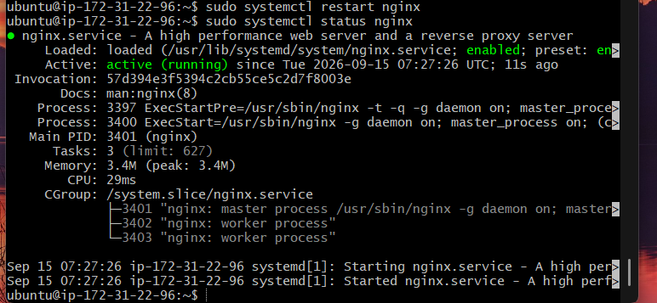

2.7 Verify that Nginx is listening on 8080
Run:
sudo ss -lntp | grep 8080
Expected output similar to:
LISTEN 0 511 0.0.0.0:8080 0.0.0.0:* users:(("nginx",...))
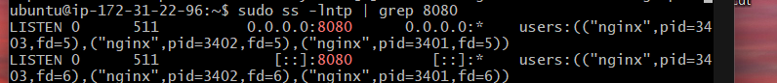

2.8 Test locally
From the EC2 instance:
curl http://localhost:8080
You should receive the Nginx welcome HTML response.
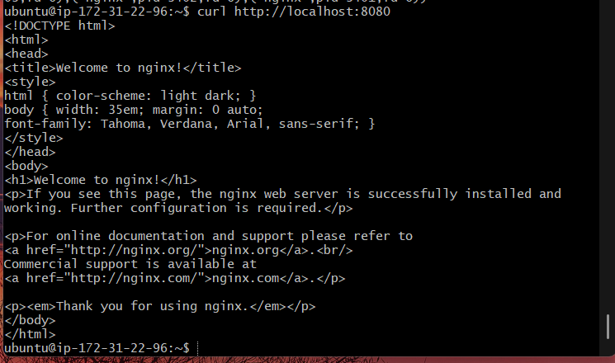

2.9 Allow port 8080 in AWS Security Group
This is important because the current security group only allowed SSH on port 22.
Go to:
AWS Console → EC2 → Security Groups → cricbuzz-sg → Inbound rules
Add:
Type: Custom TCP
Port: 8080
Source: 0.0.0.0/0
For this challenge, 0.0.0.0/0 is fine for testing. In production, you would restrict the source where possible.
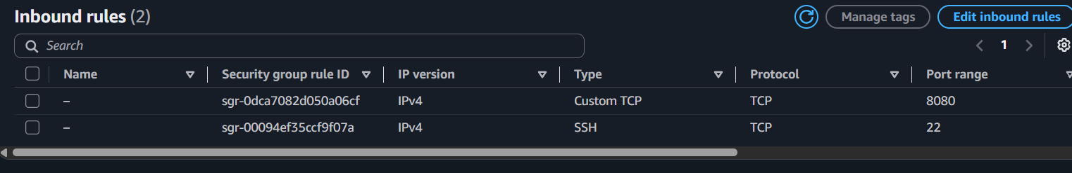

2.10 Test from your browser
Open:
http://<PUBLIC-IP>:8080
Example:
http://54.xx.xx.xx:8080
You should see the Welcome to nginx! page.
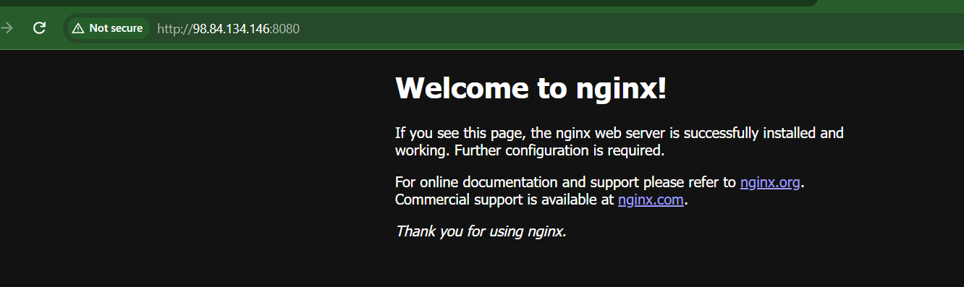
Task 3: Create a Docker-compose file for the project: https://github.com/betawins/cricbuzz-docker-hello-world.git and point it to port 8000.

Objective
Clone the provided project:
https://github.com/betawins/cricbuzz-docker-hello-world.git
and create a Docker Compose configuration that runs the application on port 8000.

Expected Architecture
EC2 Instance
│
├── Nginx → :8080 ← Task 2
│
└── Docker Compose
│
└── Cricbuzz App → :8000

3.1 Install Git
On your EC2 instance:
sudo apt update
sudo apt install git -y
Verify:
git –version
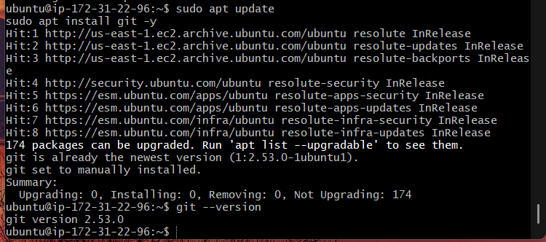

3.2 Check Docker
Run:
docker --version
If Docker is already installed, continue to 3.3.
If not:
sudo apt install docker.io -y
Start Docker:
sudo systemctl enable --now docker
Verify:
sudo systemctl status docker
You should see:
Active: active (running)
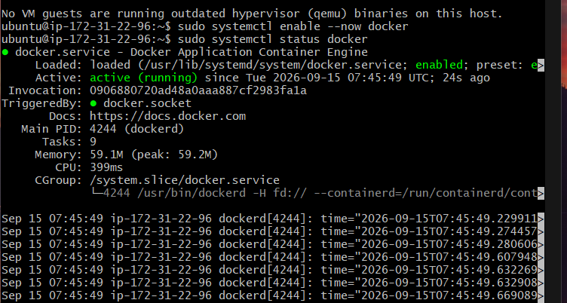

3.3 Install Docker Compose
Check whether Compose is available:
docker compose version
If you get a version such as:
Docker Compose version v2.x.x
continue.
If docker compose is not available:
sudo apt install docker-compose-v2 -y
Then verify:
docker compose version
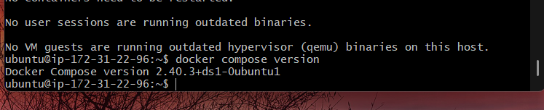

3.4 Clone the project
Go to your home directory:
cd ~
Clone:
git clone https://github.com/betawins/cricbuzz-docker-hello-world.git
Go inside:
cd cricbuzz-docker-hello-world
Check the files:
ls -la
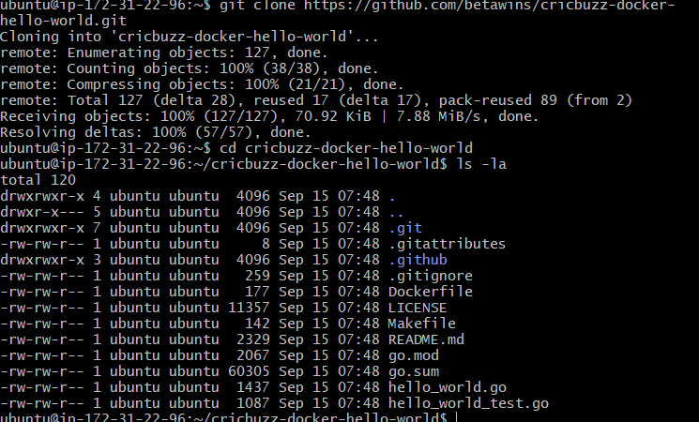

3.5 Check the existing project files
Run:
find . -maxdepth 2 -type f
Also check:
ls -la
Look for files such as:
Dockerfile
docker-compose.yml
docker-compose.yaml

Important
Before creating a new Compose file, check whether the repository already contains one:
ls docker-compose*
If it says something like:
docker-compose.yml
open it:
cat docker-compose.yml
If there isn't one, we'll create it.
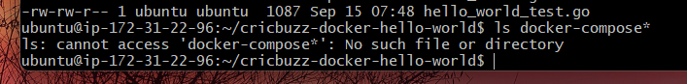

3.6 Create the Docker Compose file
If the repository does not already have a Compose file:
nano docker-compose.yml
We'll configure the application to expose port 8000.
First run:
cat Dockerfile
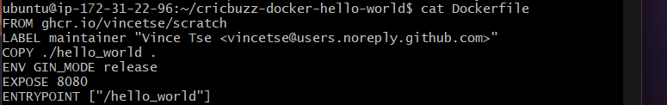
and:
find . -maxdepth 2 -type f -not -path './.git/*'

Why we're checking this
We need to know what port the application listens on inside the container.
For example, if the application listens on container port 8000, Compose would use:
ports:
- "8000:8000"
If it listens on container port 8080, we'd use:
ports:
- "8000:8080"
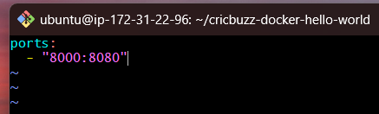
The left side is the EC2 host port, and the right side is the container port.
8000:8000
↑ ↑
host container
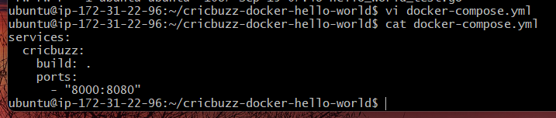

3.7 Build and start the service
Once the Compose file is configured:
docker compose up -d –build
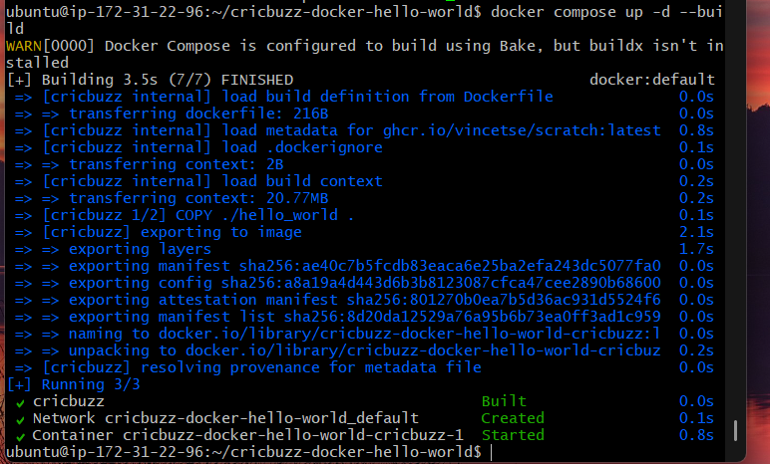
Check:
docker compose ps
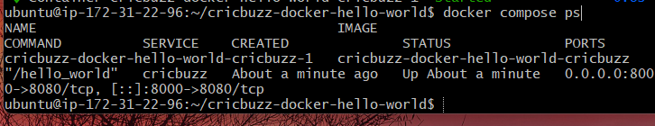
You want the container to show as running.
Then:
docker ps
You should see a port mapping similar to:
0.0.0.0:8000->8000/tcp

3.8 Test the application
From the EC2 instance:
curl http://localhost:8000
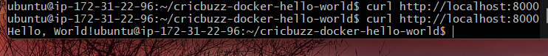
You should receive the application's response.
Also verify the port:
sudo ss -lntp | grep 8000
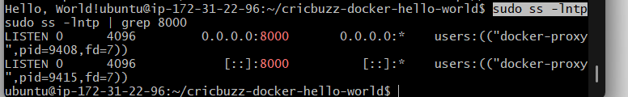

Task 4: Make the web server point to the above service so that 8080 returns the response from the Docker service.

Objective
Configure the Nginx web server so that:
http://EC2-PUBLIC-IP:8080
↓
Nginx
↓
Docker Service :8000
So, when a user accesses port 8080, they should receive the response from the Docker application running on port 8000.

4.1 Verify Docker service is running
On the EC2 instance:
docker ps
Confirm your application is running on port 8000.
Test it:
curl http://localhost:8000
Make sure you get the application response.
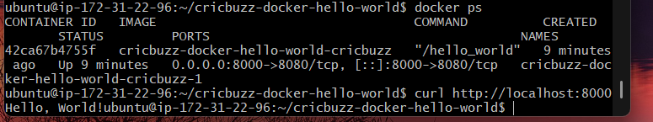

4.2 Configure Nginx reverse proxy
Open the Nginx configuration:
sudo nano /etc/nginx/sites-available/default
Replace the existing server block with:
server {
listen 8080;
listen [::]:8080;

server_name _;

location / {
proxy_pass http://127.0.0.1:8000;

proxy_set_header Host $host;
proxy_set_header X-Real-IP $remote_addr;
proxy_set_header X-Forwarded-For $proxy_add_x_forwarded_for;
proxy_set_header X-Forwarded-Proto $scheme;
}
}
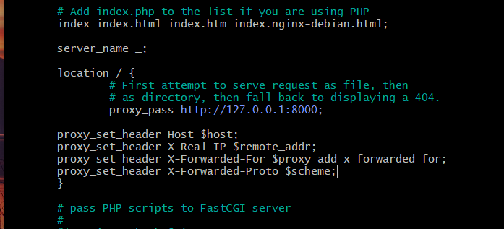

Important
The key configuration is:
proxy_pass http://127.0.0.1:8000;
This tells Nginx:
Forward requests received on port 8080 to the application running on port 8000.

4.3 Test Nginx configuration
Run:
sudo nginx -t
Expected:
syntax is ok
test is successful
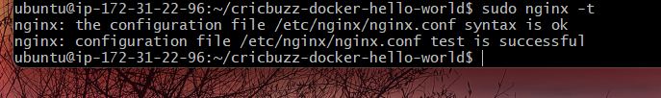

4.4 Restart Nginx
sudo systemctl restart nginx
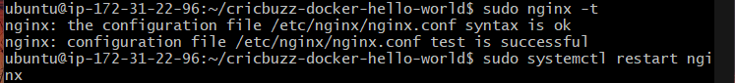
Check:
sudo systemctl status nginx
Expected:
Active: active (running)

4.5 Test through Nginx
First test from the EC2 instance:
curl http://localhost:8080
You should now get the Docker application's response, not the default Nginx welcome page.
Compare:
curl http://localhost:8000
and:
curl http://localhost:8080
The responses should come from the same application.
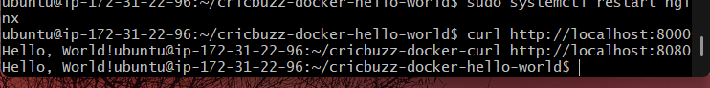

4.6 Test from your browser
Open:
http://<EC2-PUBLIC-IP>:8080
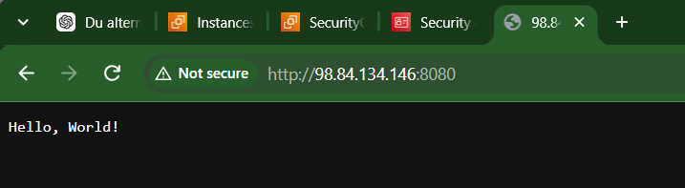
For example:
http://54.xx.xx.xx:8080
You should see the Cricbuzz Docker application response.

Task 4 architecture
EC2
│
┌─────────┴─────────┐
│ │
Nginx Docker
:8080 :8000
│ │
└───────proxy───────┘
│
Cricbuzz App

Therefore the request flow is working:
Browser
↓
EC2 :8080
↓
Nginx
↓
proxy_pass → 127.0.0.1:8000
↓
Docker Container
↓
Hello, World!

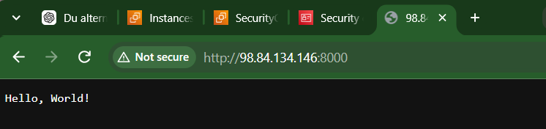
Task 5: Configure to Save the Logs in the location /var/log/cb.log

Objective
Configure Nginx so that requests coming through port 8080 are logged to:
/var/log/cb.log
Since Nginx is the reverse proxy handling the requests on 8080, we'll configure its access logs and error logs.

5.1 Edit the Nginx configuration
Open:
sudo nano /etc/nginx/sites-available/default
Update the server block to:
server {
listen 8080;
listen [::]:8080;

server_name _;

access_log /var/log/cb.log;
error_log /var/log/cb.log;

location / {
proxy_pass http://127.0.0.1:8000;

proxy_set_header Host $host;
proxy_set_header X-Real-IP $remote_addr;
proxy_set_header X-Forwarded-For $proxy_add_x_forwarded_for;
proxy_set_header X-Forwarded-Proto $scheme;
}
}

Important configuration
These two lines send both types of logs to the required file:
access_log /var/log/cb.log;
error_log /var/log/cb.log;
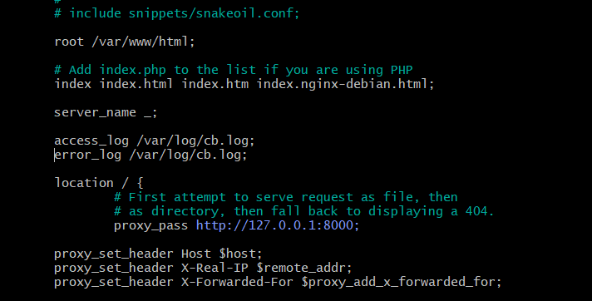

5.2 Test the Nginx configuration
sudo nginx -t
Expected:
syntax is ok
test is successful
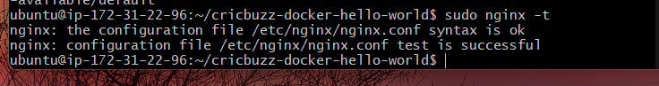

5.3 Restart Nginx
sudo systemctl restart nginx
Verify:
sudo systemctl status nginx
Expected:
Active: active (running)
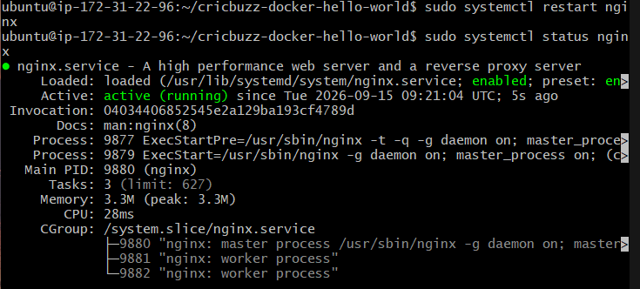

5.4 Generate a request
Make a request through Nginx:
curl http://localhost:8080
You should receive the Docker application's response.

5.5 Check the log file
Run:
sudo ls -l /var/log/cb.log
Then:
sudo cat /var/log/cb.log
You should see an access-log entry similar to:
127.0.0.1 - - [15/Sep/2026:...] "GET / HTTP/1.1" 200 ...
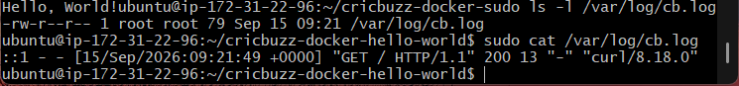
You can also monitor it live:
sudo tail -f /var/log/cb.log
In another terminal, run:
curl http://localhost:8080
You should see a new log entry appear.
Press:
Ctrl+C
to stop tail.

5.6 Verify the complete flow
Run:
curl http://localhost:8080
Then:
sudo tail -n 10 /var/log/cb.log
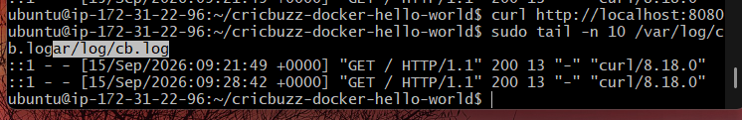
The expected flow is:
Client
│
│ :8080
▼
Nginx
│
│ proxy_pass
▼
Docker :8000
│
▼
Application response
│
└──────► /var/log/cb.log

Task 6: Write the Log rotate configuration for the above file.

Objective
Configure Linux logrotate so that /var/log/cb.log does not grow indefinitely.
We will configure it to:
- Rotate the log daily
- Keep 7 old log files
- Compress old logs
- Create a new cb.log
- Reload Nginx after rotation

6.1 Check that logrotate is installed
Run:
logrotate --version
If it is not installed:
sudo apt update
sudo apt install logrotate -y
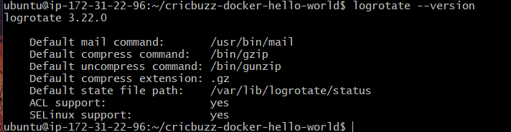

6.2 Create the logrotate configuration
Create:
sudo nano /etc/logrotate.d/cb
Add:
/var/log/cb.log {
daily
rotate 7
compress
delaycompress
missingok
notifempty
create 0640 www-data adm
postrotate
systemctl reload nginx > /dev/null 2>&1 || true
endscript
}
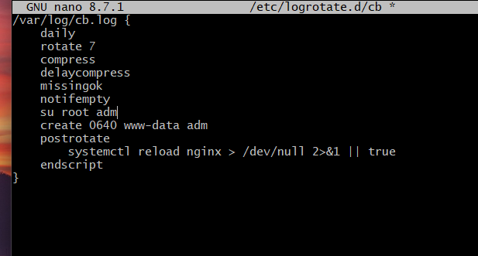

What each option means
Configuration | Meaning
daily | Rotate the log every day
rotate 7 | Keep 7 old log files
compress | Compress rotated logs
delaycompress | Compress from the second-oldest rotation
missingok | Don't report an error if the log doesn't exist
notifempty | Don't rotate an empty log
create 0640 www-data adm | Create a new log with specified permissions
postrotate | Execute commands after rotation
systemctl reload nginx | Reload Nginx after rotation

6.3 Check the configuration
Run:
sudo logrotate -d /etc/logrotate.d/cb
-d means debug mode. It doesn't actually rotate the log.
You should see information indicating that /var/log/cb.log is being considered.
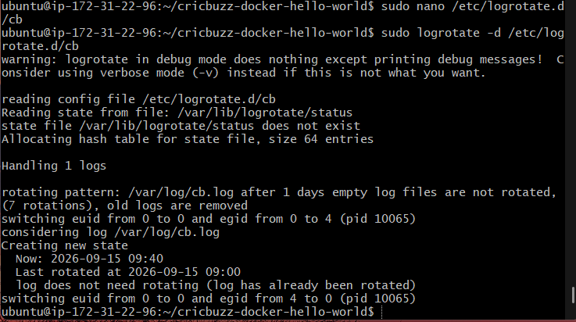

6.4 Force a rotation for testing
Because we don't want to wait until tomorrow, run:
sudo logrotate -f /etc/logrotate.d/cb
-f means force rotation.

6.5 Check the rotated files
Run:
sudo ls -lh /var/log/cb.log*
You should see something similar to:
-rw-r----- 1 www-data adm ... cb.log
-rw-r----- 1 www-data adm ... cb.log.1
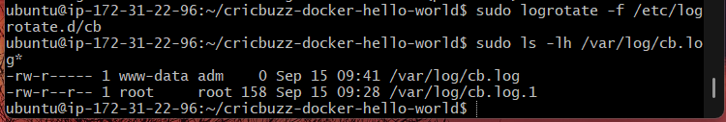
After subsequent rotations, compressed files will appear, for example:
cb.log
cb.log.1
cb.log.2.gz
cb.log.3.gz
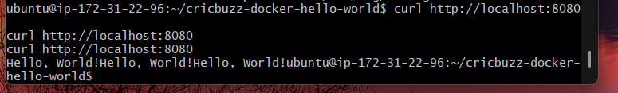

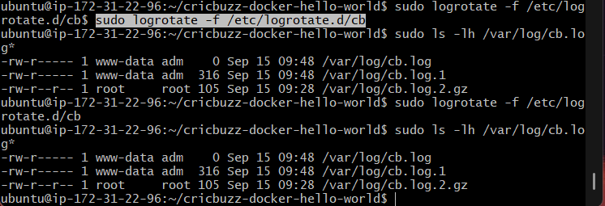

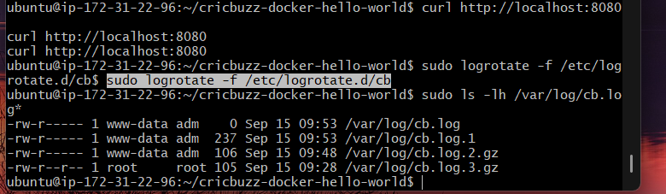

6.6 Generate another request
curl http://localhost:8080
Then check:
sudo tail -n 10 /var/log/cb.log
You should see the new request in the newly created log.
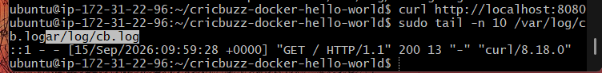

Final Challenge Architecture
After Task 6, our complete setup should look like:
AWS EC2
│
│ :8080
▼
Nginx
Reverse Proxy
│
│ :8000
▼
Docker Container
│
▼
Cricbuzz Application

Nginx Logs
│
▼
/var/log/cb.log
│
▼
logrotate
│
┌─────────────┴─────────────┐
▼ ▼
cb.log.1 cb.log.2.gz

I provisioned an Ubuntu EC2 instance using Terraform. I installed Nginx and configured it to listen on port 8080. I deployed the Cricbuzz application using Docker Compose on port 8000. Nginx acts as a reverse proxy and forwards requests from port 8080 to the Docker service on port 8000. I configured Nginx access and error logs to /var/log/cb.log and configured logrotate with daily rotation, retention, compression, and Nginx reload after rotation.

